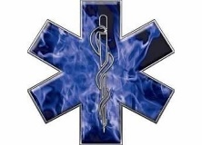 SELCAS 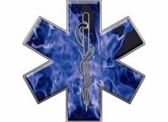 NOW HIRING!!
FULL TIME BASIC AND PARAMEDIC

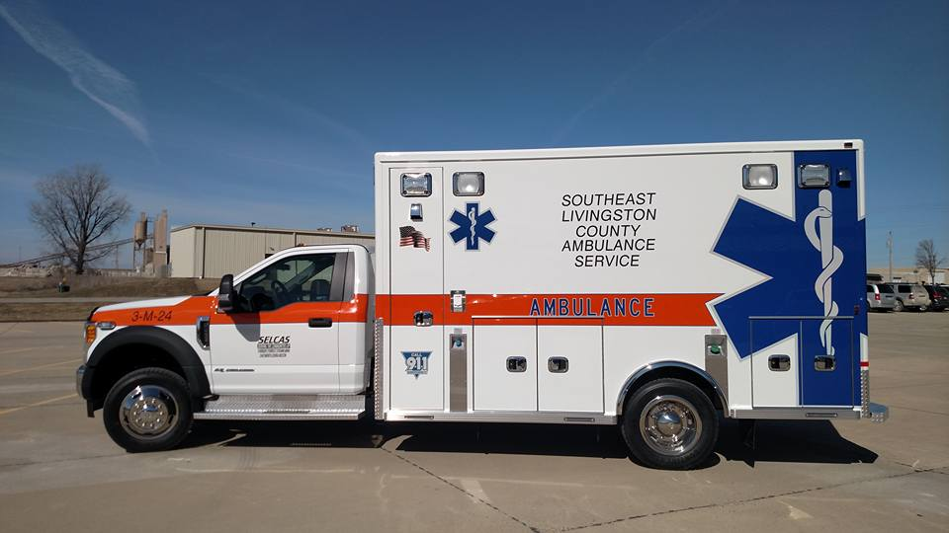

2024 PAY SCALE
PARAMEDIC $23/HR
EMT BASIC $17.50/HR
HEALTH/DENTAL/VISION INSURANCE
2 WEEKS PAID VACATION
RETIREMENT PLAN
Email selcas45@gmail.com Ph 815-848-2145 (Jeremy)

